IDAHO HIGH SCHOOL ACTIVITIES ASSOCIATION

Hall of Fame

APPLICATION

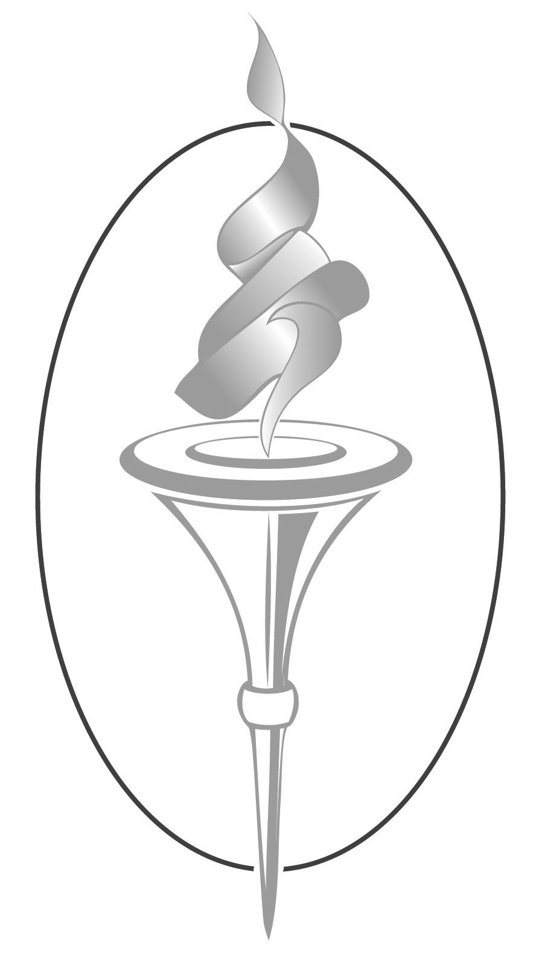

Name Date Submitted

Return application by January 6 to:
Idaho High School Activities Association
8011 Ustick Rd. Boise, ID 83704
Tel: 375-7027 Fax: 322-5505 Email: hammonsj@idhsaa.org

*Application must be typed.

*Use this form or a similar computer-generated form.

*Applications may not exceed four pages.

*A maximum of three letters of recommendation and/or

supporting materials may be included.

*Please include a recent portrait-style photograph.

Idaho High School Activities Association

HALL OF FAME APPLICATION

Name:
Address: |  |  |  | Email:
 | Street
 | City | State | Zip
Contact Ph #: |  |  | Date and Place of Retirement:

Education History (high school / college)

Professional Career (list positions in chronological order-include dates & # of years at each)

Professional Organizations (past & present – local, state, national – offices held)

Honors / Awards / Coaching Records

Application of:______________________________________________ (Hall of Fame page 2)

Contributions (detail areas of involvement in athletics/activities throughout your career)

Impact (which contributions have made the greatest impact on IHSAA athletics / activities?)

Career Highlights (most satisfying accomplishments, memorable moments, etc.)

Philosophy of High School Activities

